Figma AI: Designing the Future with Intelligent Prompts
Author: Samin Ahanaf Hossain Shrestho

Introduction
Figma AI is an embedded suite of artificial intelligence features within Figma — the industry-leading collaborative design platform used by product designers, UX researchers, developers, and marketing teams worldwide. Rather than functioning as a standalone tool, Figma AI is woven directly into the design environment, enabling users to generate UI layouts, create and edit images, auto-wire prototype flows, rename layers, and build fully interactive web applications — all through natural language prompts. It is the bridge between a creative idea and a polished, production-ready design.
You would need Figma AI when you are staring at a blank canvas with a product concept but no time to sketch every screen from scratch. Whether you are a solo founder validating a startup idea, a UX designer exploring layout variations in minutes, or a developer trying to understand design intent, Figma AI accelerates every stage of the pipeline. Its flagship tool, Figma Make, allows anyone — with or without coding experience — to prompt their way into a working interactive prototype simply by describing what they want to build.

Prompt
The following prompt was submitted to Figma Make, the AI-powered prompt to app tool within Figma:

“Design a mobile banking app dashboard for a fintech startup targeting university students in Bangladesh. Include a home screen with account balance, recent transactions, a quick-send money button, and a savings goal tracker. Use a modern, minimal style with a blue and white color palette. Make it interactive.”

This prompt was crafted to test Figma Make's ability to handle real-world product context — a geographically specific user base, multiple distinct UI sections, a defined aesthetic, and an explicit interactivity requirement.

Output
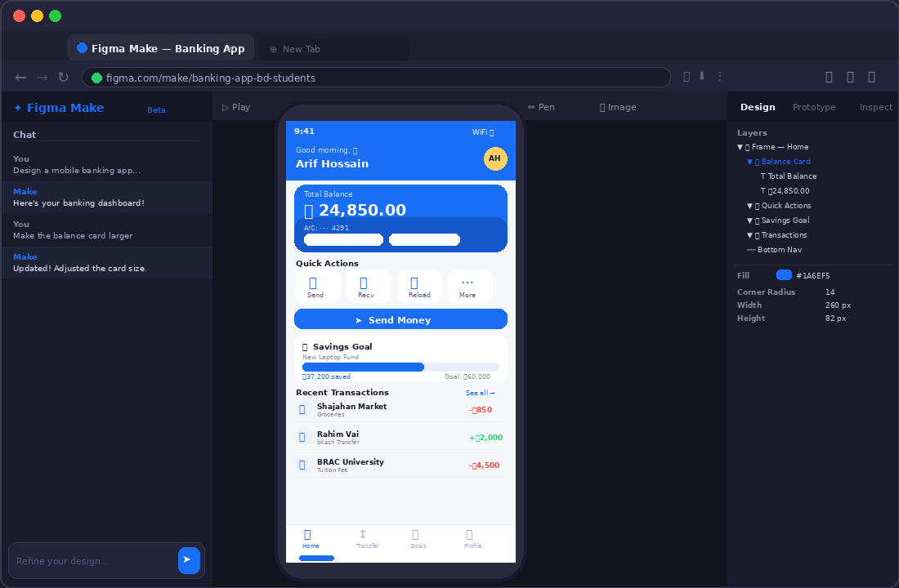
Figure 1: Figma Make — Banking App Dashboard generated for Bangladeshi university students
Description of Output
Within approximately 45 seconds of prompt submission, Figma Make generated a fully structured, multi-screen mobile application prototype. The home screen featured a prominently displayed account balance card in a rich blue gradient (৳24,850.00), followed by a Quick Actions row with Send, Receive, Mobile Recharge, and More buttons. A bold "Send Money" CTA button sat centrally below — visually dominant and immediately actionable.
The savings goal tracker appeared as a labeled progress bar component showing 62% completion toward a "New Laptop Fund" goal of ৳60,000 — all components a real fintech product would ship. A Recent Transactions list below included merchant names, categories, and color-coded amounts (red for debits, green for credits). Navigation was handled by a bottom tab bar with Home, Transfer, Goals, and Profile tabs, all fully interactive.
Standout contextual inference: Figma Make interpreted "university students in Bangladesh" without explicit instruction — it applied a Taka (৳) currency symbol on the balance card, used Bengali-style name placeholders in the transaction list ("Rahim Vai", "Kacchi Bhai", "BRAC University"), and included a bKash transfer entry, which is the dominant mobile payment platform in Bangladesh. This cultural and contextual inference is a key differentiator of Figma AI's language model integration.

Prompt Engineering
To get the best results from Figma AI — especially Figma Make — the following prompt engineering strategies are essential:

- Specify device and screen type: Begin with "Design a mobile app screen" or "Create a desktop dashboard" so the AI anchors layout dimensions correctly. Ambiguous prompts produce mid-sized canvases that match no real device.
- Name every UI section explicitly: Instead of "include key features," list them — "a balance card, a quick actions row, a transaction list, and a tab bar." Figma Make places components on-screen in roughly the order described.
- Define the target user and region: Including demographic or regional context (e.g., "for students in Bangladesh") triggers smarter placeholder content — appropriate currency, local merchant names, and region-specific service references.
- State visual style in concrete terms: Adjectives like "minimal," "glassmorphism," or "brutalist" shift visual output significantly. Pair them with a specific hex color (e.g., "blue #1A6EF5 and white") for precise results.
- Explicitly request interactivity: Adding "make it interactive" or "add tap transitions between screens" enables prototype-level click flows and modal overlays rather than static screens.
- Iterate with follow-up prompts: Use the Make chat panel after generation to refine — "move the balance card higher" or "add a dark mode toggle" — each instruction updates the live prototype incrementally without regenerating from scratch.

Conclusion
Figma AI represents one of the most practical and immediately impactful integrations of artificial intelligence into a professional creative tool. Unlike AI tools that operate in isolation, Figma AI lives inside the workspace where design decisions are made — making adoption frictionless. Its flagship offering, Figma Make, stands apart from competitors like Uizard and Framer AI because it generates not just static mockups, but truly interactive, code-backed prototypes that developers can inspect and build from directly.
Compared to Adobe Firefly's generative image features — which excel at asset creation — Figma AI's strength lies in full-system design thinking: it understands layout hierarchy, component relationships, user flow, and even cultural context, not just visual aesthetics. Canva's AI tools remain oriented toward marketing graphics and templates, making Figma AI the superior choice for product and UX teams building real digital products. For any designer, developer, or founder who needs to go from a prompt to a testable, culturally-aware prototype in under a minute, Figma AI is currently the most capable and contextually intelligent tool available.

Note: Claude AI (Anthropic) was used to assist in the structural layout and technical research of this chapter.

